**Jeffrey Donaldson**

Sir Jeffrey Donaldson is the MP for Lagan Valley.

He is the DUP whip in the House of Commons and appears to have played a prominent role in the negotiations with the Tories in respect of the “confidence and supply” agreement , which bolstered May’s government.

Given that the Northern Ireland Affairs Committee, which included Ian Paisley, had recommended that the government, in certain circumstances, set up a fund for victims and survivors of Libyan supplied PIRA Semtex bombs, I wondered if this issue had been included in the agreement.

Several months on, despite asking my MP, Paul Girvan, several times, I have had no answer. I was told by his election agent, that “Jeffrey was dealing with it”.

So how happy should that make me?

Donaldson has been involved with a string of local companies.

QUBRIC NI 614008 which he said would help projects in working class Protestant areas, is dormant.

CIPBCR Ltd NI 611071 set up to provide management consultancy services other than financial management.

CIPCRI NI 628604 which now has only one officer-Kingsley Donaldson.

Kingsley is an interesting chap. The brother of Jeffrey, he is an ex army officer. He is a director of NI Water, of Scobie McIntosh and of Global Conflict Resolution. He also describes himself as having been “strategy adviser to the head of the British Army”. No small job, that.

But back to Jeffrey. Aside from sharing roles with his brother, Jeffrey is also a director of the Centre for Democracy and Peacebuilding, where he has a fellow director, Liam Maskey, brother of Alex.

So , how likely is it that Jeffrey was minded to push Mrs May for a deal on the Libyan Semtex issue? Is he conflicted in any way? Does he have business interests which would get in the way?

In 2012 he visited Qatar for three days and declared that he had received a donation worth £3,000 to £4,000. Nice work if you can get it.

In 2014 he visited Egypt, receiving a donation worth £3,300 to cover a four day trip to Cairo.

In November 2015 he was appointed a Trade Envoy to Egypt and spent a week there , where most women are subject to genital mutilation.

If , Dear Reader, you are in any doubt about Jeffrey’s links with the Arab world and particularly Libya, read the blurb from CIPCR, set out below.

Then decide this. How likely is it that Jeffrey would push for Libyan compensation?

CIPCR International partnered the The Westminster Foundation for Democracy (WFD) in delivering a major programme in countries from across the Middle East and North Africa (MENA).

WFD specialises in parliamentary strengthening and political party development; works at national, regional and local levels; and is uniquely placed to draw directly on the expertise and involvement of the Westminster political parties.

This joint programme involved a number of aspects including exploring the lessons learned from the Northern Ireland peace process and how elements of those lessons might be applicable to other countries and groups in MENA.  The programme partner was the Arab Network for Tolerance (ANT) which is a forum where activists, academics, media professionals and youth can come together to identify new strategies for improving human rights.  The Network was formed in 2008 by the Ramallah Centre for Human Rights Studies.

Causeway has provided a number of tailored study visits to Northern Ireland by Middle East groups to see at first hand the transformation which has begun, and continues, in society generally and both within and across communities.  Delegates from Palestine, Lebanon, Iraq and Yemen visited Belfast for the week-long programme of events.

[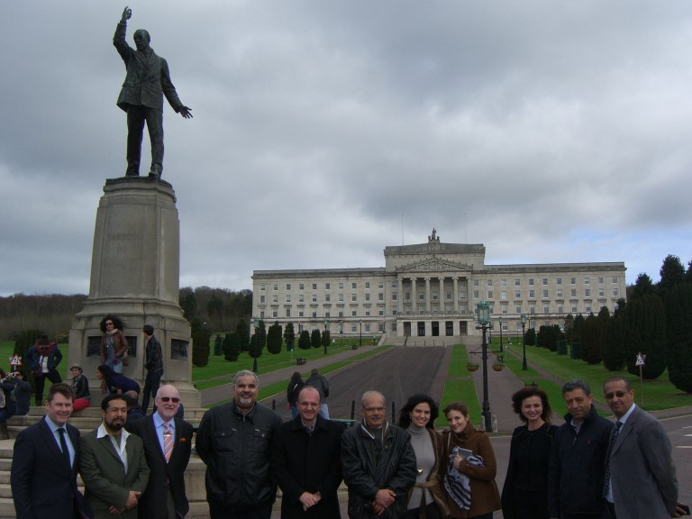](http://www.cipcr.org/wp-content/uploads/20120319-Group-at-Carson-Statue.jpg)

WFD sponsored study visit by Arab Network for Tolerance

The programme was specifically aimed at the higher level of engagement.  Delegates met and were briefed by some of the key players in the Northern Ireland peace process, past and present.  These included the Office of the First Minister and Deputy First Minister, former and serving Human Rights commissioners; the Chief Executive of the Equality Commission; the Victims Commission; the Police Ombudsman and the Policing Board as well as the leadership of the PSNI (Police Service of Northern Ireland).  Delegates also visited a number of community groups who are working across the sectarian interface in Belfast to deliver comprehensive programmes focussed on rights and justice.  Representatives from the major political parties in Northern Ireland also briefed delegates on their respective parties’ views on human rights and equality.

CIPCR International has also supported the ANT holding a conference for its members in Beirut.  This conference, hosted jointly by the ANT and the Permanent Peace Movement, brought together Human Rights groups from across MENA to discuss their approaches to Transitional Justice and Tolerance.  The Chairman of CIPCR gave the keynote address at the conference.  CIPCR associates also conducted a number of bi-lateral meetings with groups attending the Conference to explore ways in which we could better assist their development.  This has led to significant engagements on potential activity in Libya, Bahrain and Sudan and  with groups in Yemen, Iraq, Lebanon and Palestine in order to support their development.  These workshops focused on developing the capacity and capability of the individual groups in their own countries.

[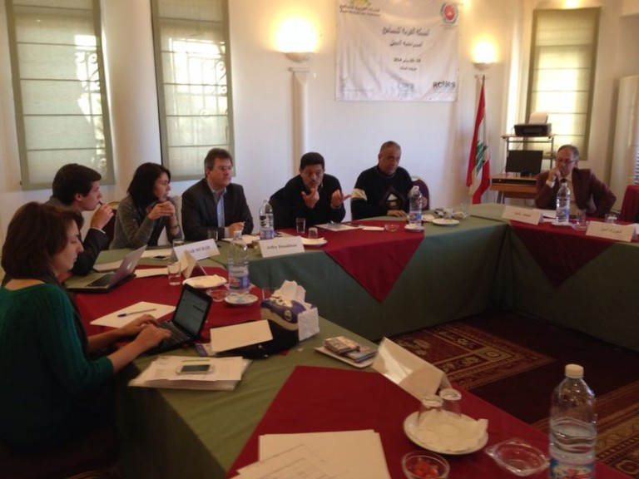](http://www.cipcr.org/wp-content/uploads/Conference.jpg)

Causeway Chairman addressing ANT delegates in Beirut January 2014

CIPCR International is working on developing a longer term programme of activity with the ANT to strengthen the power of their network through collaborative practices and shared agendas. . It is clear that the experience of Northern Ireland is very relevant to the objectives of the ANT.  It is not the purpose of either the wider project or this specific visit to replicate arrangements existing in Northern Ireland or to address specific issues but rather to discuss them in an open and transparent way as a contribution to the debate which is part and parcel of the Network’s role and remit.