**State surveillance**

It would be of great assistance to any state if it knew the whereabouts of each citizen at all times.

In 1976, while some arms of the state were keen to achieve the Orwellian dream, technology was lagging behind.

VENGEFUL was the “secret system” by which the registration marks of vehicles were collated, if the car had been stolen or was suspected of use by terrorists. There was a main computer and 50 remote terminals It covered 6% of all vehicles in NI and 27,000 enquiries were made each day. Rather naively a civil servant said that the terrorists did not know about it. Anybody who sat at a checkpoint could have worked that one out.

VENGEFUL 2 was more sophisticated and was able to track the recorded movements of a car for the previous six months.

[Subsequently, number plate technology read plates instantly from covert positions. Later tracking devices, monitored from satellite or from a circling aircraft were deployed. See the case of the “ Craigavon 2”]

Surveillance was also provided by the “P” check system. Cards were created for each person who came under attention. Astonishingly , in 1976, a quarter of a million citizens were recorded on cards, as being of “potential danger to the state”. This amounted to about one person in six in Northern Ireland.

Proposals were afoot that this system should also hold the records of all citizens and their addresses. After much debate, about amongst other things, the infant concept of data protection. The state was keen to computerize and update the cumbersome card index system.

This project became known as Project EQUINOX.

The control by the army was coming to an end and the Chief Constable Kenneth Newman was putting forward his proposals for the re-introduction of police primacy. Sadly, the Brits were not even then on the same page as the RUC. Whilst the administrative problems might be overcome, the chaps in the clubs of Whitehall were more than uneasy about those Ulstermen getting hold of intelligence.

What, you might ask, could the problem be?

Well, it is the perennial problem. HMG was running NI, not for its inhabitants but for the greater good of the United Kingdom. So pesky policemen getting the hold of army intelligence would not be a happy thing.

S S Bampton [and all who sailed in him/her] sent a secret memo to J B Bourne [no surely not him-perhaps his father?] recording his thoughts about the troublesome Paddies. Jack Hermon’s proposals were described by Bourn as ‘sketchy”. No doubt the plan was to keep the really juicy intelligence as far away from the RUC as possible.

What this letter exposes, if it needs to be said, is the mindset of Whitehall and the idiocy of the Loyalist community which believed – and still believes, that the British were their friends, allies and protectors.

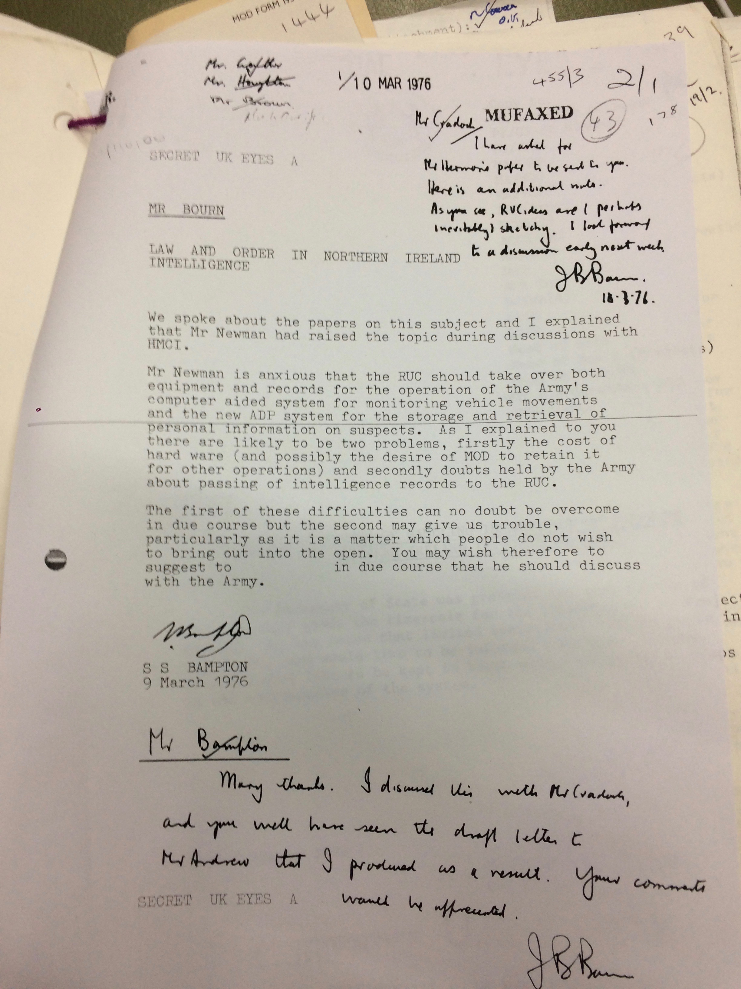

And so it came about that in Northern Ireland, the state promoted a variety of intelligence agencies, each working to its own agenda. The RUC SB, MI5, the army, MI6 [re the Republic of Ireland] and who knows what else.

There is no doubt that the EQUINOX and VENGEFUL systems were upgraded and that other hardware and software was deployed.

So, let’s think of a problem. Ardoyne. “Shitty place, minister, we come under constant attack there” Let’s use technology. The entirety of Ardoyne was surveyed from Oldpark Police Station, with the exception of a few “blind spot” streets. They had to be patrolled and some others too, so as not to reveal the technology. There are not many exits from that area and I’ve no doubt that they were covered too.

So what is my point?

Any bomb team, leaving Ardoyne, either singly or together would have been recorded by the state. Hence the team that murdered my parents and the team that planted the Shankill bomb are known to the state.

The RUC, the PSNI, the HET , the Police Ombudsman and particularly Drew Harris have lied about this to me and to others , for years.

The 1970s technology, being debated at Whitehall was , by 1990 infinitely more powerful.

Victims and survivors need to bear this in mind.