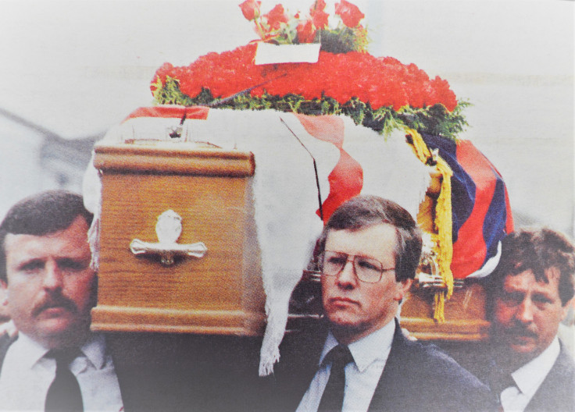On the 11th July 1994, a PIRA murder gang, five in total, including a female, held two vulnerable  OAPs hostage, they were mistreated, one thrown down stairs.  At around 9 a.m.  one gunman left the cover of the OAPs’ home and murdered Ray Smallwoods in front of his wife.  The murderer was a well know state player in the PIRA and was identified at the scene, however, the RUC refused to prosecute the case. ULET would call on all those who might have information relating to this murder to come forward. We would ask that all those who gave information about a black Hyundai Poney VXI5486 to contact us.  We would also ask, that any member of the Security Forces who are aware of the specifics of disappearing evidence, in relation to the case, come forward.  All contact will be treated in a highly confidential manner.

Published by Ulidia Legacy & Educational Trust